CROP HEALTH ASSISTANT

1.1 INTRODUCTION

Artificial intelligence (AI) is the simulation of human intelligence processes by machines, especially computer systems. These processes include learning (the acquisition of information and rules for using the information), reasoning (using rules to reach approximate or definite conclusions) and self-correction. Particular applications of AI include [expert systems](https://searchenterpriseai.techtarget.com/definition/expert-system), [speech recognition](https://searchcrm.techtarget.com/definition/voice-recognition) and [machine vision](https://searchenterpriseai.techtarget.com/definition/machine-vision-computer-vision).

Python is one of the most popular programming languages used by developers today. Guido Van Rossum created it in 1991 and ever since its inception has been one of the most widely used languages along with C++, Java, etc . In our endeavour to identify what is the best programming language for AI and neural network, Python has taken a big lead.

1.2 OBJECTIVES OF RESEARCH

a) Enabling quick and easy detection of plant diseases by using the machine’s intelligence for the farmers.

b) To avoid inexperienced pesticide usage which causes the development of long-term resistance of the pathogens, severely reducing the ability to fight back. Timely and accurate diagnosis of plant diseases is one of the pillars of precision agriculture.

c) Making sure the resources are available to the people concerned with crop health.

1.3 PROBLEM STATEMENT

“DEEP NEURAL NETWORKS BASED RECOGNITION OF PLANT DISEASES BY LEAF IMAGE CLASSIFICATION”

The current statement focuses on plant disease recognition in order to provide efficient plant disease protection which is closely related to the problem of sustainable agriculture and climate change.

Our project is to detect the plant diseases and showing the affected part of the leaf by image processing techniques .We also explain the experimental analysis of our methodology.

Samples of seven classes of plant diseases have been collected for detection.

2 .REVIEW OF LITERATURE

“Plant disease epidemiology requires expansion of it’s current methodological and theoretical underpinnings in order to produce full contributions to global food security and global changes”, derived from International Rice Research Institute.

The current statement focuses on plant disease recognition in order to provide efficient plant disease protection which is closely related to the problem of sustainable agriculture and climate change.

Our project is to detect the plant diseases and showing the affected part of the leaf by image processing techniques .We also explain the experimental analysis of our methodology. Samples of seven classes of plant diseases have been collected for detection.

3 .DATA COLLECTION

The training and testing data consisting of seven classes of plant diseases ,namely Apple Block Rot ,Corn Cercospora ,Grape Esca ,Potato Early Blight ,Squash Mildew, Strawberry Leaf Scorch and tomato Yellow Leaf Curl virus.

The source is [www.Kaggle.com](http://www.Kaggle.com)

|  |
| --- |
| C:\Users\DELL\Pictures\Screenshots\Screenshot (225).png |
| C:\Users\DELL\Pictures\Screenshots\Screenshot (228).png |

4. METHODOLOGY

I. IMPORTING THE KERAS LIBRARIES – The following libraries are being imported:

a) Sequential- Sequential API allows the model layer by layer.

b)Dense-It is a linear operation on the layers input vector.

c)conv 2D-It is a simple application of filter to an input.

d)Max Pooling-By using these we can neglect 75% of unwanted features.

e)Flatten-It is used to convert any dimension to 1D

II. INITIALIZE THE CNN MODEL

III . ADD CONVOLUTION LAYER- This convolves the image with the feature detector and gives the feature map.

IV . ADD POOLING LAYER- Removes the spacial invariance.

V . ADD FLATTEN LAYER- This becomes the input layer for the ANN model.

VI . ADDING DENSE LAYERS FOR ANN- It includes two hidden layers.

VII . COMPILING THE MODEL

VIII . PREPROCESSING THE IMAGES

IX . TRAINING THE MODEL- The machine is trained with seven classes of plant diseases.

X . SAVING THE MODEL

XI . TESTING THE MODEL

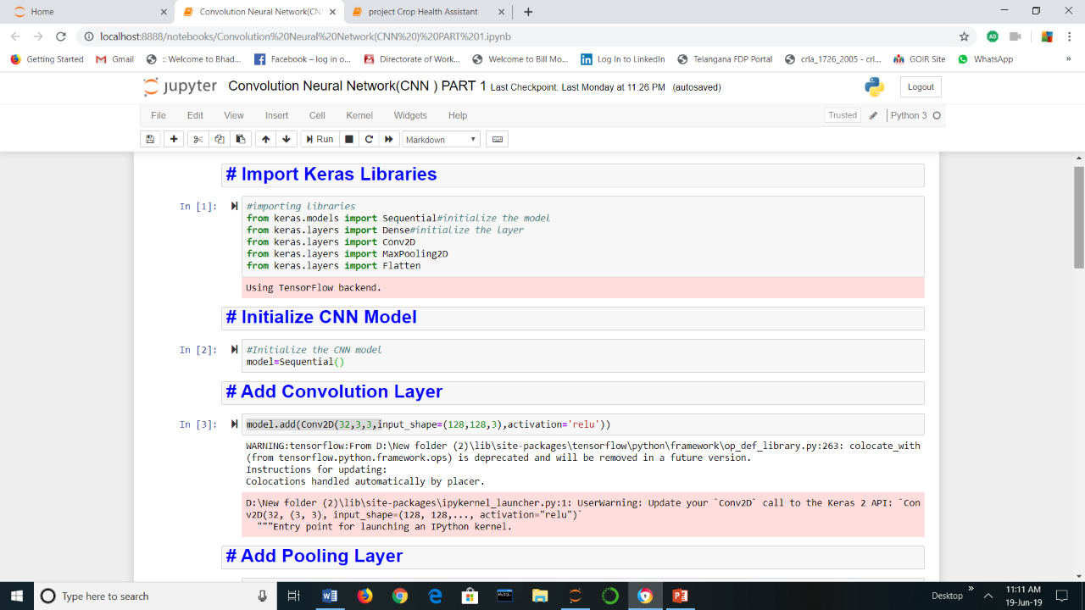

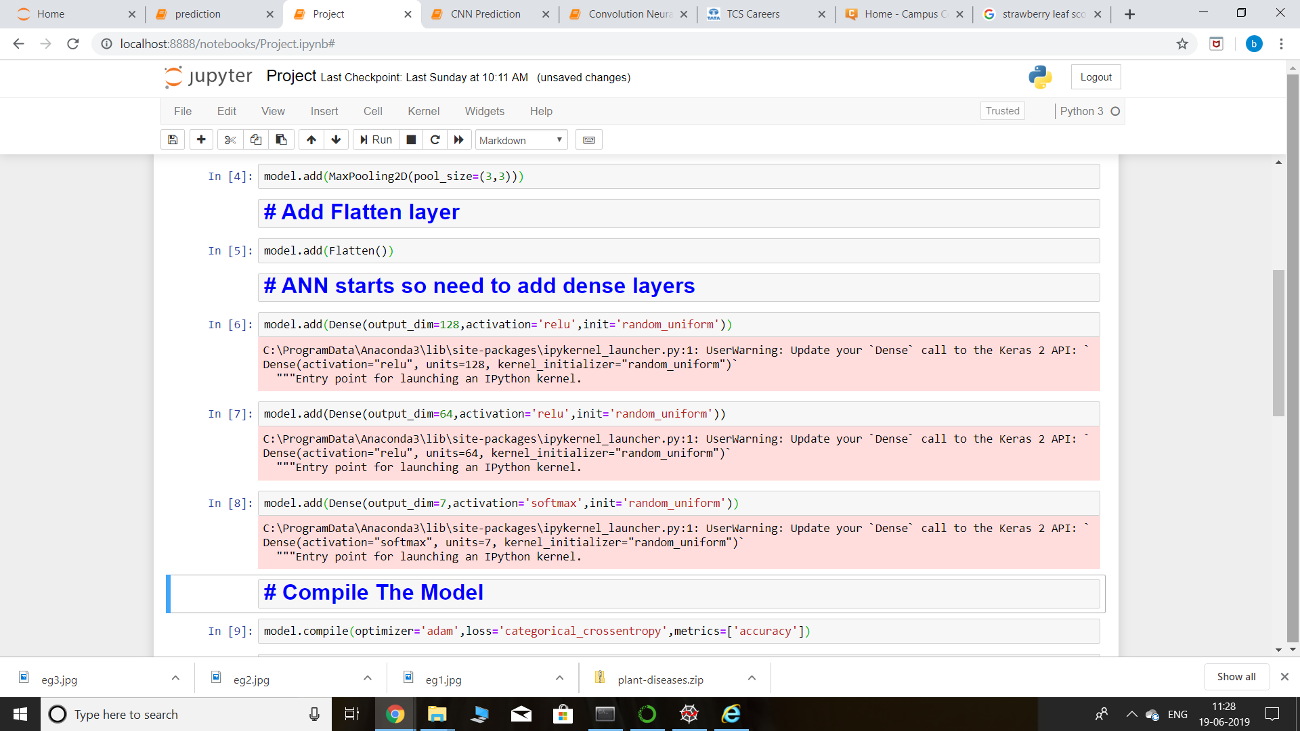

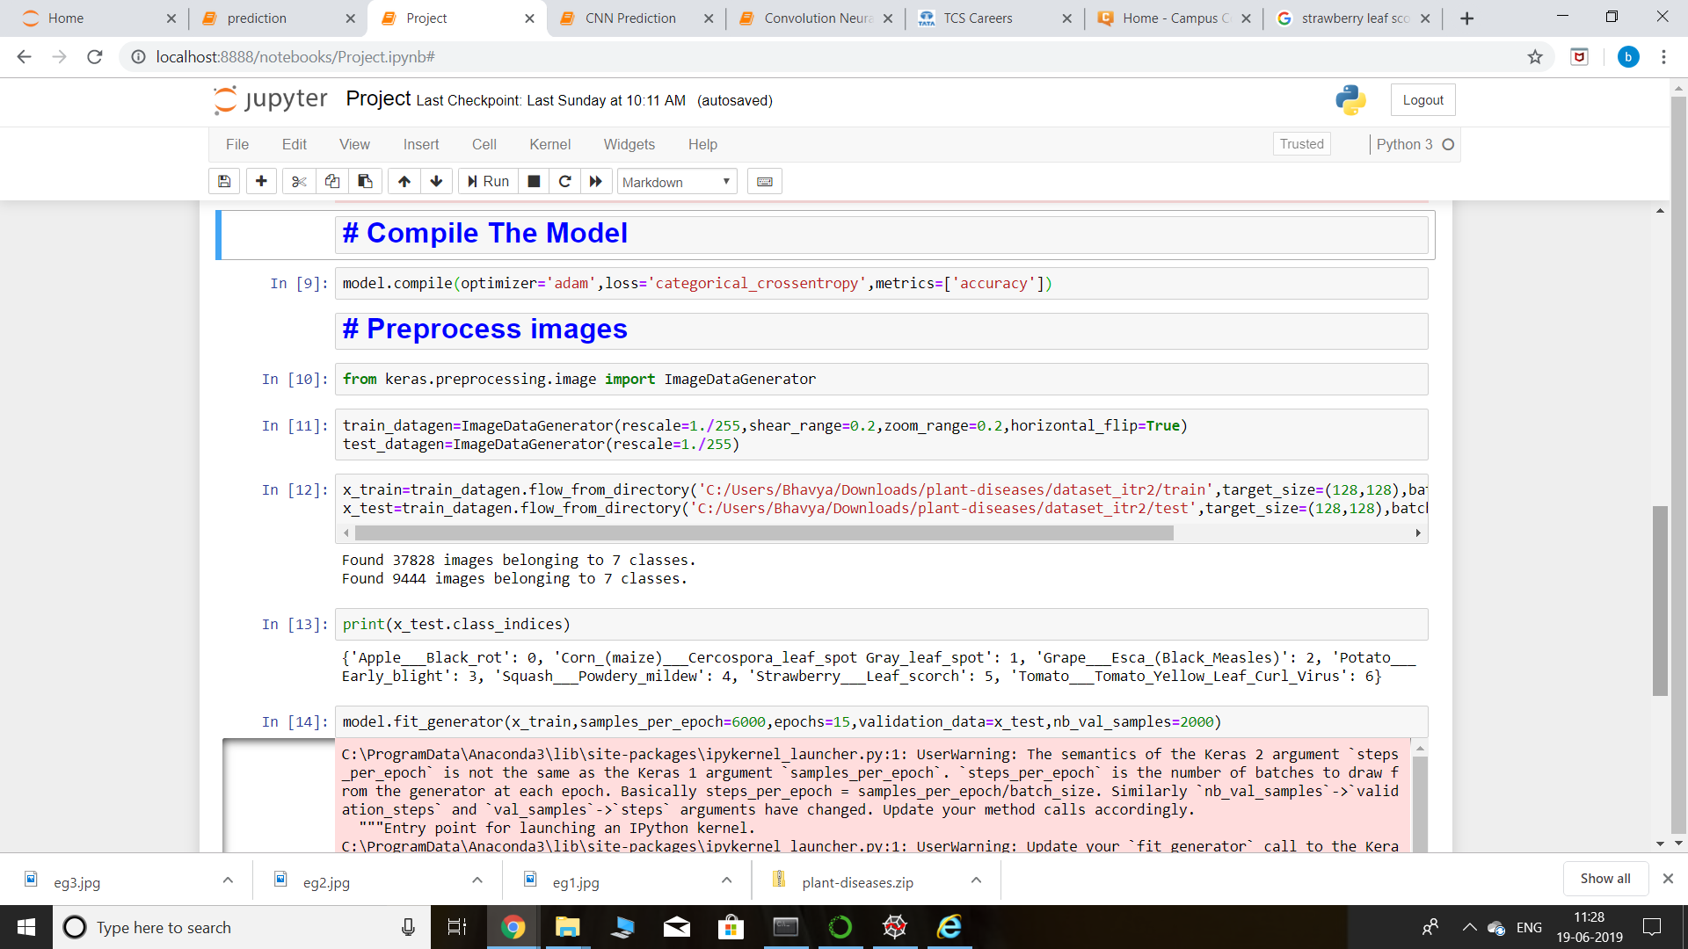

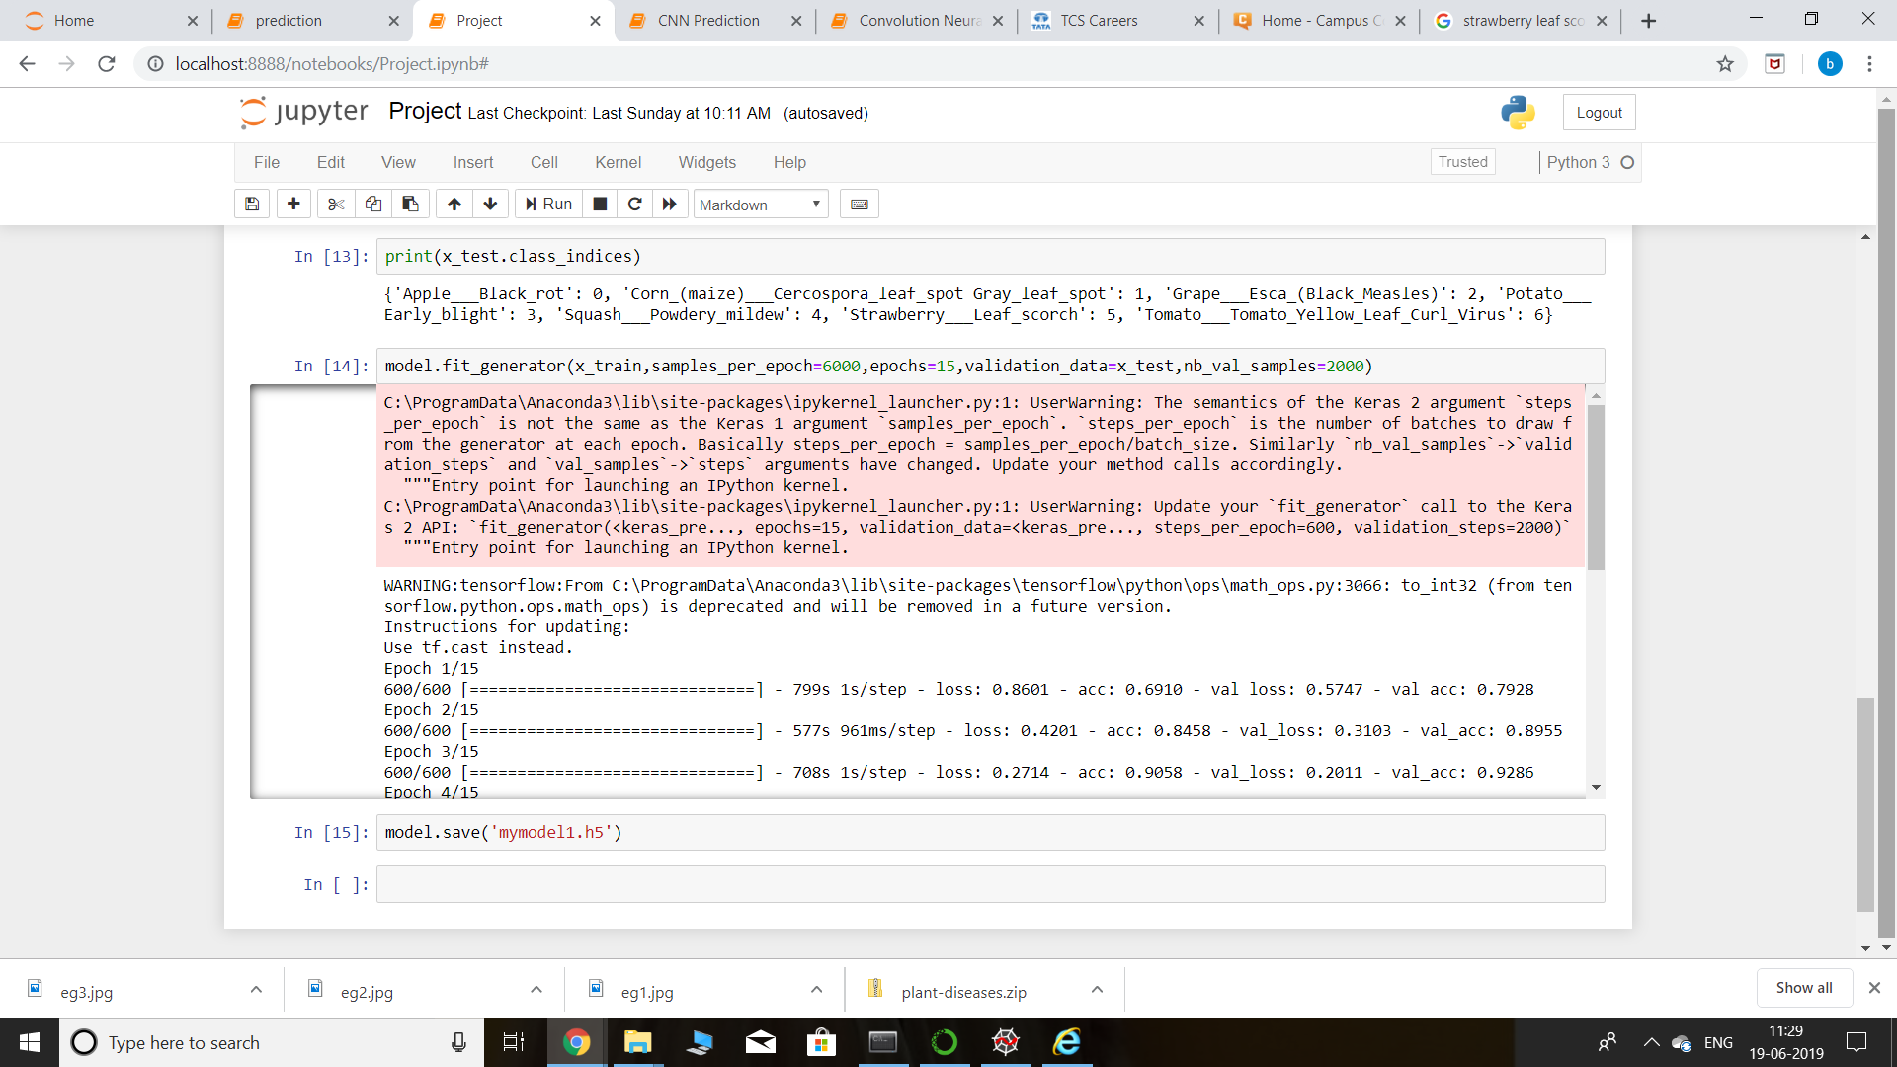

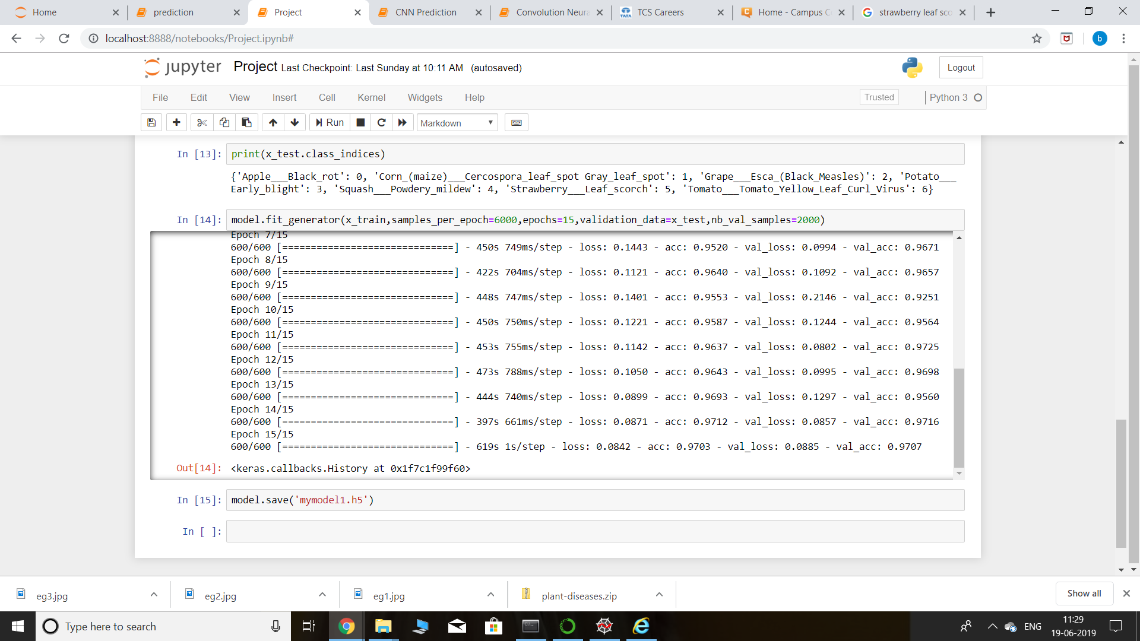

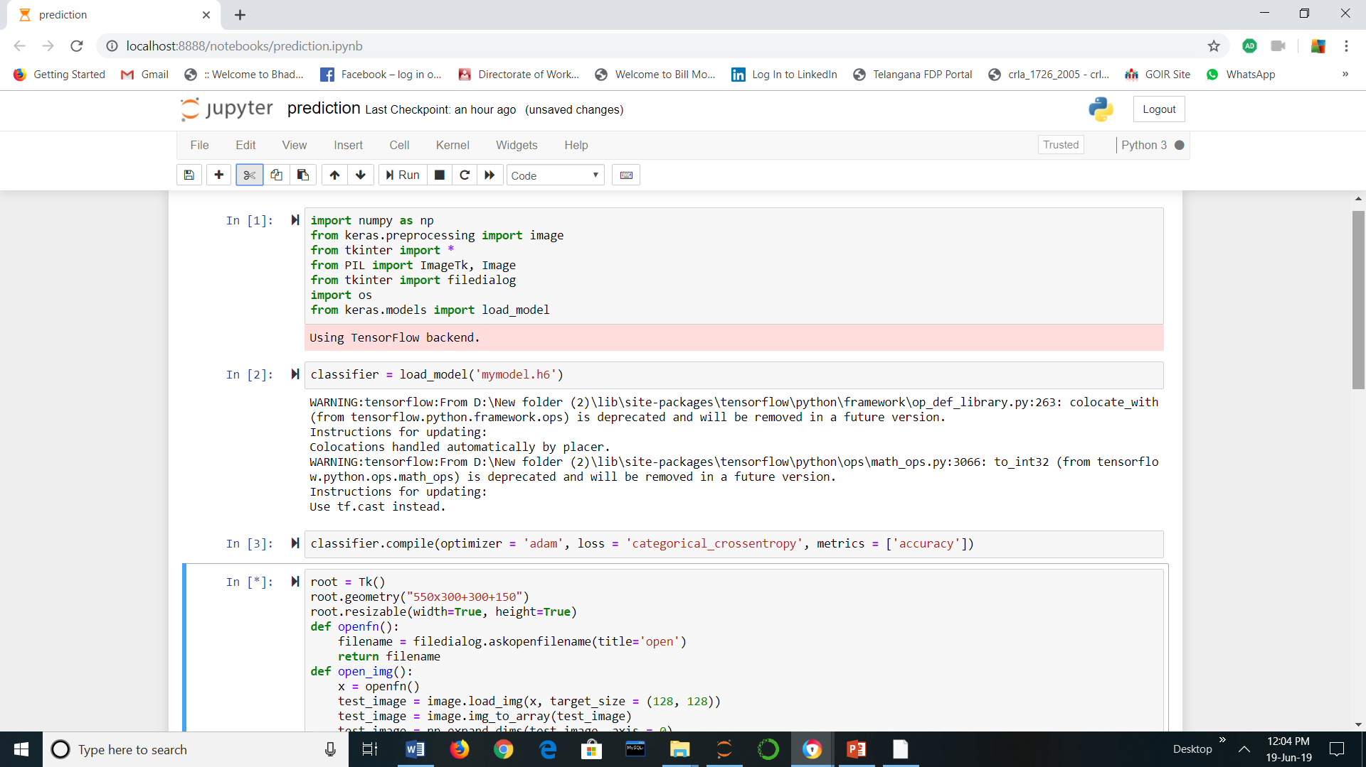

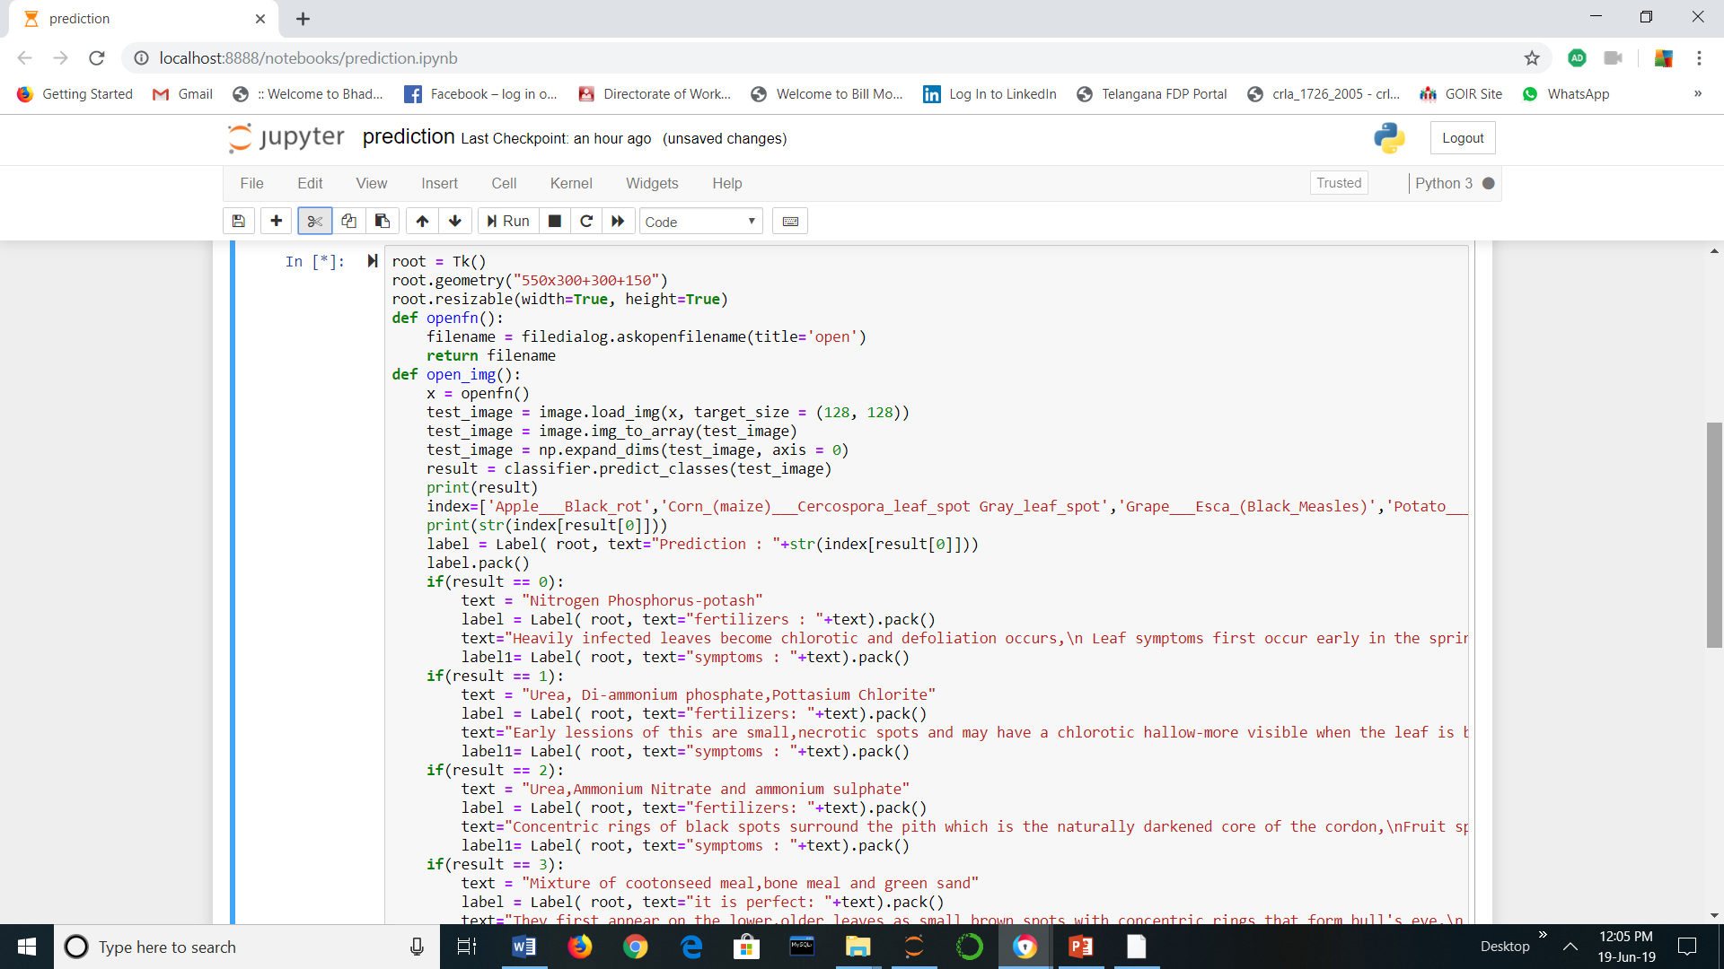

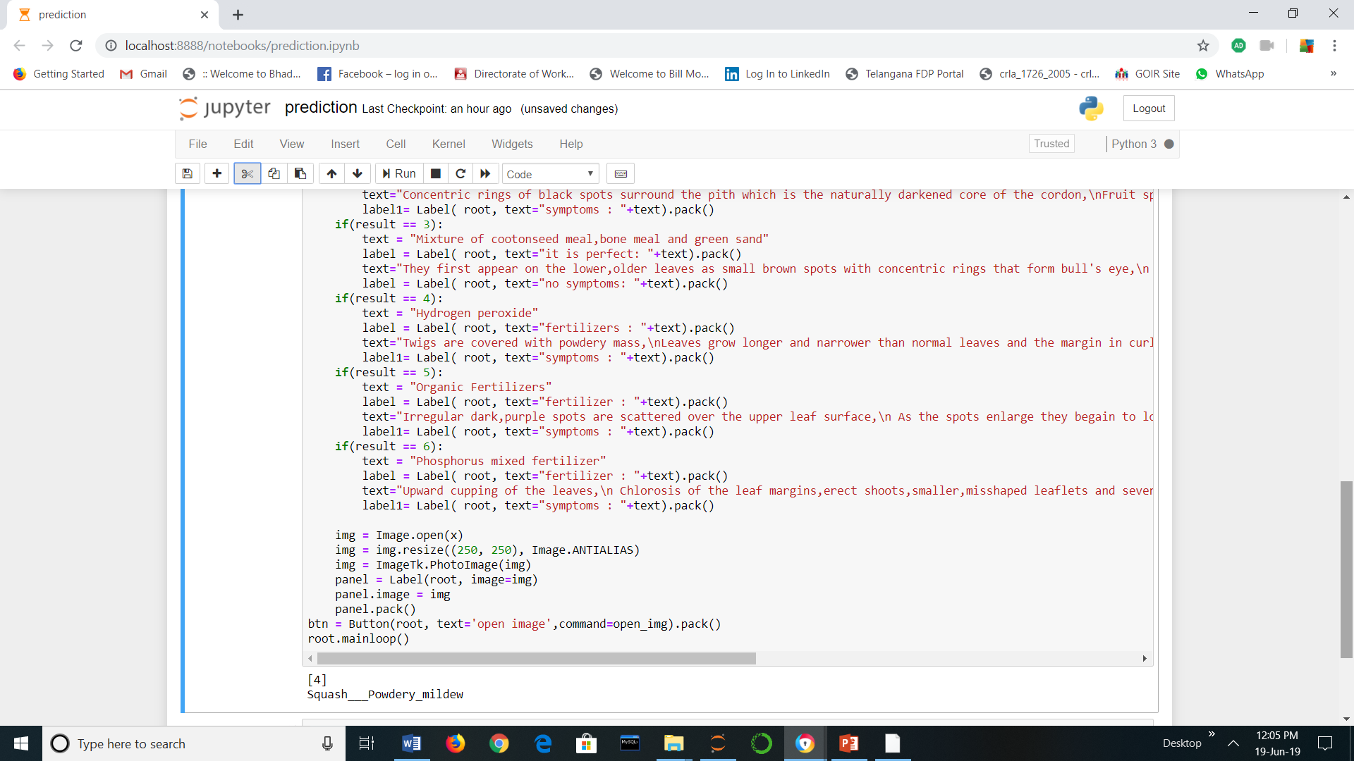

4.1 EXPLORATORY DATA ANALYSIS

4.1.1 FIGURES AND TABLES

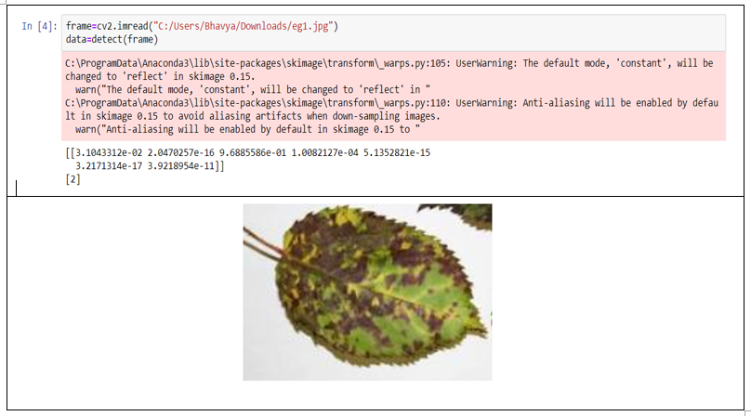 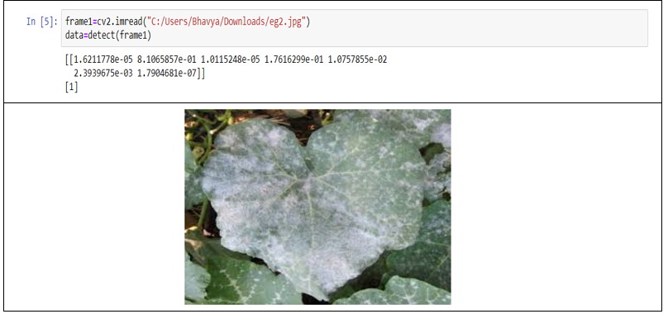

4.2 DATA MODELLING

The algorithm used is Convolutional Neural Network.

A convolutional neural network (CNN) is a specific type of artificial neural network that uses perceptrons, a machine learning unit algorithm, for supervised learning, to analyze data.

CNNs apply to image processing, natural language processing and other kinds of cognitive tasks.

Like other kinds of artificial neural networks, a convolutional neural network has an input layer, an output layer and various hidden layers.

Some of these layers are convolutional, using a mathematical model to pass on results to successive layers. This simulates some of the actions in the human visual cortex.

CNNs are a fundamental example of deep learning, where a more sophisticated model pushes the evolution of artificial intelligence by offering systems that simulate different types of biological human brain activity.

5 .FINDINGS AND SUGGESTIONS

FINDINGS-

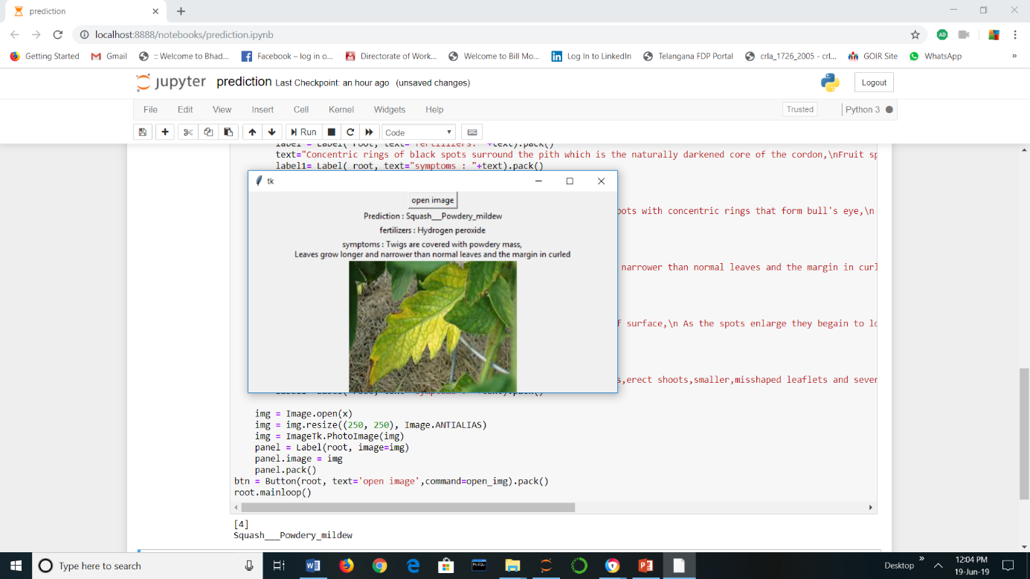

SUGGESTIONS:

The dataset can be increased by collecting more images of other crop diseases and adding various other plant disease classes which will enable a more general way of detecting the diseases and helping the community.

6 .CONCLUSION

The above model using convolutional neural network framework has helped us to predict the crop diseases with 97.03% accuracy which is of great help to farmers and the research scientists who would like to make advances in future.

It is also observed that it is not influenced by scale of input data and perform better when data is heterogeneous.